NAME:S.SMRITHI

REG NO:192412059

COURSE CODE: ECA1803 \ OPTOELECTRONIC AND OPTICAL COMMUNICATION

CO1-AT1

The situation:
A telecom company wants to lay a 60 km fiber cable from its central office to a business building. It will carry 10 Gb/s now and should handle 100 Gb/s later. The light used is at 1550 nm. The cable must also survive tight bends where it enters the building.
You are the design engineer. Before anything is installed, you must decide whether this plan will actually work, and fix it if it will not.
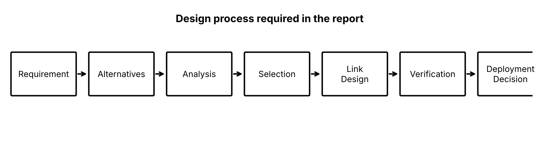
Figure 1: The design process the report must follow

2. What you have to decide

Which fiber to use
Fiber A has a tiny core (4 µm) and fiber B has a big core (25 µm). Calculate the numerical aperture (NA) and the V-number to see which one carries a single mode and which carries many modes. For a 60 km high-speed link, single-mode fiber is the usual choice. You also pick an ITU-T type: G.652.D, G.655 or G.657.

Whether enough light reaches the receiver
Start at +3 dBm and subtract all losses: the fiber loss over 60 km, the connectors, the splices, and the bend at the building entry (0.8 dB with G.652.D, 0.1 dB with G.657.A). The result must be above the receiver sensitivity of −20 dBm plus a 6 dB safety margin. You also name the biggest loss source.

Whether the pulses stay sharp
Over distance, light pulses spread out (chromatic dispersion). If they spread beyond the 100 ps bit period, neighbouring bits overlap and errors appear. Calculate the spreading for two fiber types. If it is too much, work out the length of dispersion-compensating fiber (DCF) needed. Also check PMD, a polarization effect that matters more at 100 Gb/s.

Whether the amplifier helps or hurts
An amplifier boosts the signal but also adds noise. Calculate the OSNR (optical signal-to-noise ratio) before and after the amplifier and compare it with the required 17 dB.

The final verdict
Put everything in a verification table, draw a block diagram of the final link, and answer YES (I would deploy it) or NO (here is my redesign), with numbers to support the answer.
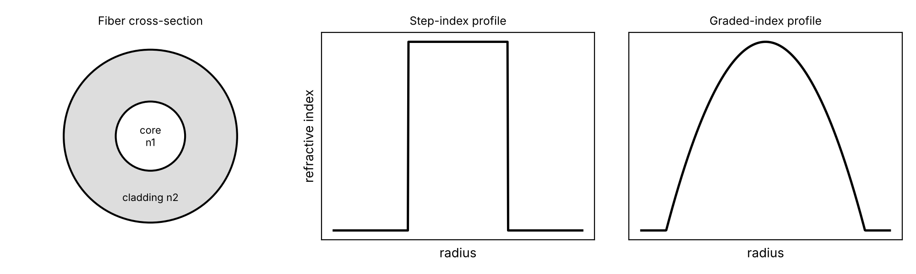
Figure 2: Fiber structure and index profiles
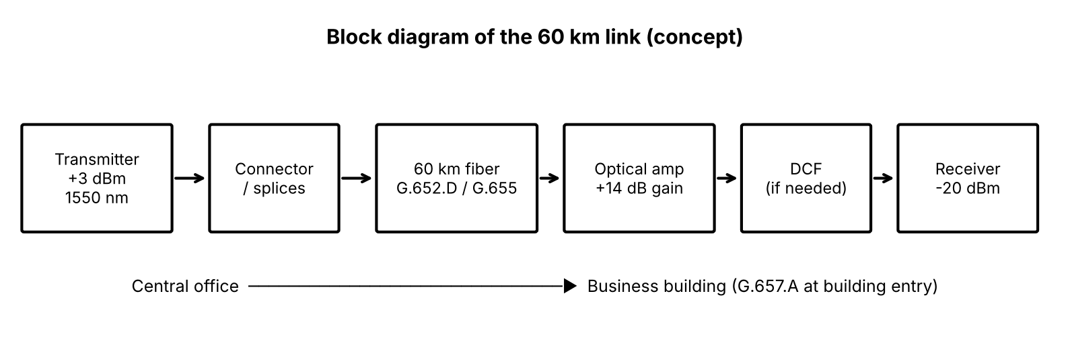
Figure 3: Conceptual block diagram of the 60 km link

3. How the report is organized

Part | What you do | Marks
Stage 1 | Understand the requirement; write a Design Requirement Statement | 10
Stage 2 | Choose the fiber / propagation type (NA, V-number, modes) | 15
Stage 3 | Power budget and received power | 15
Stage 4 | Dispersion, DCF length, PMD | 15
Stage 5 | OSNR and amplifier | 10
Stage 6 + Final design | Verification table, block diagram, integrated design | 20
Final decision | YES / NO with justification | 15

Four of the stages end with a sentence you complete: "I recommend ___ because ___." The marks reward your reasoning, not only the calculations.

4. Key formulas:
- NA = sqrt(n1² − n2²)
- V = (2πa/λ)·NA; single-mode when V < 2.405
- Modes: step-index M ≈ V²/2; graded-index M ≈ V²/4
- Chromatic broadening: Δτ = D·Δλ·L
- Complete compensation: D1·L1 + D_DCF·L_DCF = 0
- PMD = 0.1·√L; beat length L_B = λ/B
- OSNR (dB) = signal power (dBm) − noise power (dBm)

5. In one line
Check, with calculations and reasons, whether a 60 km, 1550 nm, 10 Gb/s link (upgradable to 100 Gb/s) will work, make four justified design decisions, and finish with a defended YES/NO deployment decision.

